Design Thinking For Software Engineers
Lab-3
E-learning platforms fail to keep learners engaged
Name: Nivedh Sunil Roll No.: 24BTCE111
1. Aim of the Experiment
The aim of this experiment is to apply the Design Sprint methodology by following the Empathize, Define, Ideate, Prototype and Test stages to design a user-centred solution for improving engagement and course completion in e-learning platforms. The experiment focuses on understanding real learner and instructor challenges related to UI usability, content delivery, pacing and interactivity and validating proposed solutions through user feedback rather than assumptions.
2. Problem Context
Students, instructors and working professionals increasingly rely on e-learning platforms for academic learning, certification and upskilling. However, many users struggle with poor UI design, long non-interactive videos, text-heavy lessons, confusing navigation, rigid pacing and lack of doubt-clearing mechanisms. These issues often result in frustration, low motivation, superficial completion for certificates and high dropout rates. Instructors also face difficulties in identifying quality courses and monitoring learner engagement, reducing the overall effectiveness of online education systems.
3. Empathize
Key Observations
- What frustrates users most?
  - Users became frustrated with long, non-interactive videos, dense text blocks, lagging playback, timed quizzes for complex topics and difficulty finding quality courses. Instructors were annoyed by low engagement and poor discovery tools.
- Where do users hesitate or seek help?
  - Users hesitated when solving timed problems, navigating confusing dashboards and searching for interactive features or doubt-clearing options. Students paused frequently when instructions were unclear.
- What makes users feel confident or unsafe?
  - Clear visuals, smooth playback, short modules and visible progress indicators increased confidence. Lack of interaction, unclear explanations and pressure-based timers made learners feel stressed, leading to skipping content or quitting.
Activities Performed
- Reviewed interview notes and empathy maps created in Lab 2 for students instructors and working professionals using e-learning platforms
- Observed users navigating existing e-learning applications while starting courses watching lessons and attempting quizzes
- Noted hesitation points confusion during navigation reactions to long content timed tasks and difficulty in clearing doubts
- Recorded emotional responses such as frustration boredom stress and loss of motivation when interacting with current platforms
Empathy Map
Name: Santhosh KV
Age: 45
Occupation: Professor

Name: Ridit Santhosh
Age: 14
Occupation: Student

Name: Shijith M
Age: 28
Occupation: Working IT professional

User Insights
- Learners abandon courses when platforms prioritize content volume over engagement and clarity.
- Users lose motivation quickly when navigation is confusing or videos lag.
- Students feel discouraged and quit when they cannot ask doubts or are pressured by timers.
- Instructors lose trust in platforms when it is difficult to identify quality, engaging courses.
- Learners skip long or repetitive content when it feels disconnected from their goals.
- Visual polish raises expectations, but poor explanations drive dropout.
4. Define Stage
- Objective
  - To clearly define the core problem faced by users of e-learning platforms based on insights gathered from interviews and observations.
- Problem Statement
  - Learners need a way to stay engaged and complete online courses with confidence because confusing interfaces, long non-interactive content, unresolved doubts, and rigid pacing cause frustration and high dropout rates.
- How Might We (HMW) Question
  - How might we design an e-learning platform that keeps learners motivated through clear navigation, interactive learning, and flexible pacing so they confidently finish their courses?
5. Ideate
Brainstormed Ideas
- Adaptive learning paths with level detection personalized pacing adjustable timers and confidence-based progression
- Micro lessons and interactive checkpoints including five-minute modules quizzes after concepts practice mode and engagement gates before certificates
- Rich visual learning using animations simulations visual summaries and story-based explanations
- Doubt resolution and support through AI tutors live chat peer discussion boards and instructor office hours
- Instructor tools and discovery systems such as course preview dashboards quality ratings learner analytics and dropout heatmaps
Idea Selection
A learning system that blends personalization bite sized lessons, visual explanations, doubt clearing and instructor analytics into one continuous experience.
6. Prototype Stage
Objective
The objective of the prototype is to create a low-fidelity representation of an adaptive e-learning experience that demonstrates how learners can progress through short interactive lessons with flexible pacing, access doubt-clearing support, and receive clear feedback on their progress. The prototype aims to test whether these features reduce frustration, increase confidence, and encourage course completion while also helping instructors evaluate and assign high-quality courses.
First Screen- Home Screen
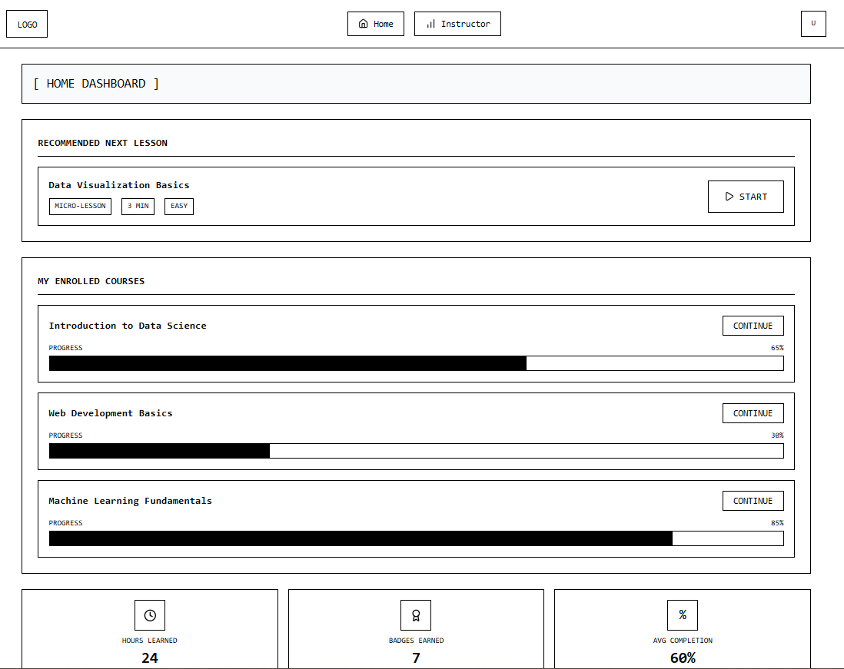

Second Screen- When Clicked on Start/Continue
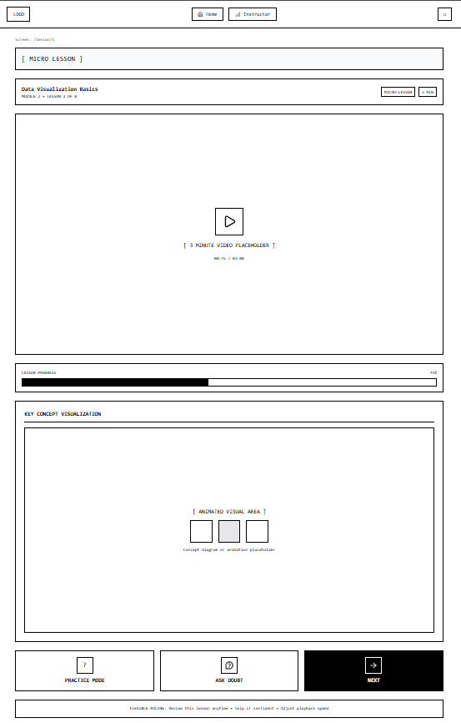
Second Screen- Section A-When Clicked on Ask Doubt
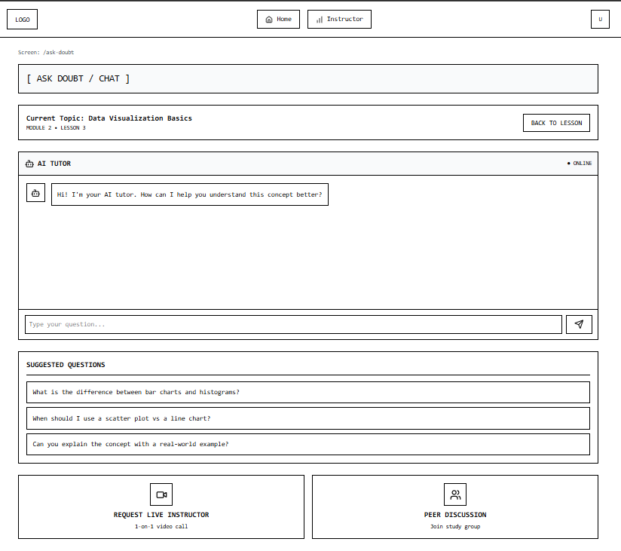

Second Screen- Section B-When Clicked on Practice Mode
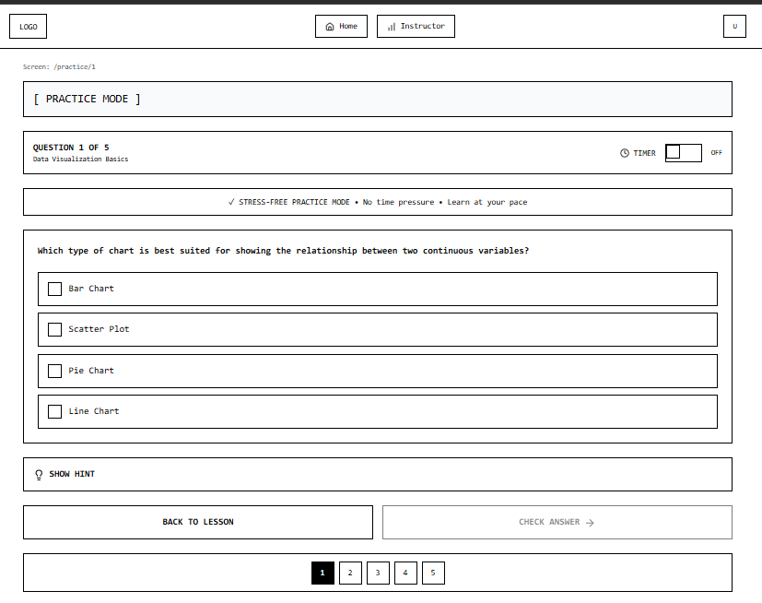

Third Screen-When Clicked on Instructor
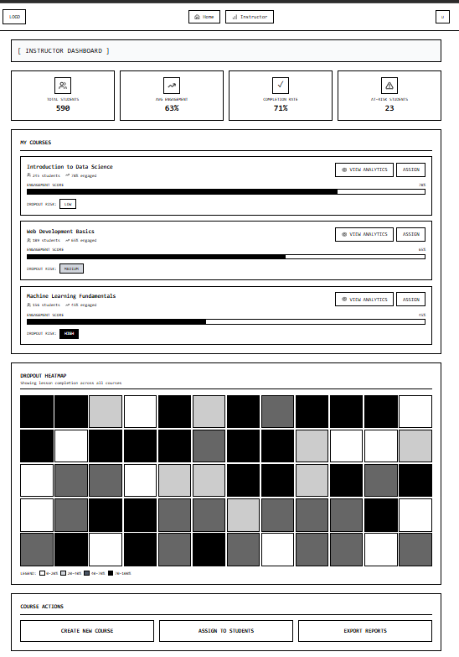

Fourth Screen- When Clicked on View Analystics
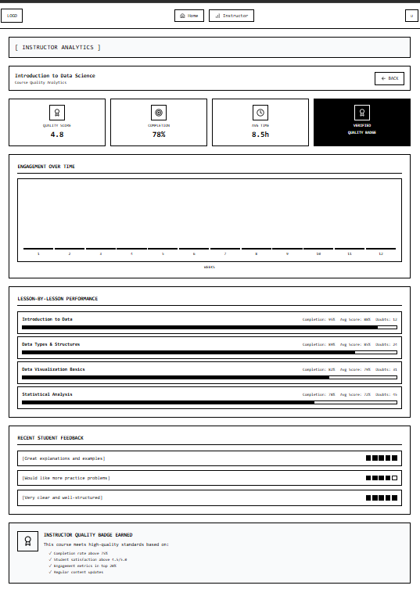

Prototype Description
- A personalized home dashboard with recommended next lessons progress tracking and enrolled courses
- Micro lesson screens featuring short videos animated concept visuals and lesson progress indicators
- Practice mode with optional timers stress free mode hints and multiple question navigation
- Ask Doubt screen with AI tutor chat suggested questions live instructor requests and peer discussion options
- Instructor dashboard showing course completion engagement metrics dropout heatmaps and analytics tools
- Instructor analytics pages with lesson level performance quality scores feedback summaries and quality badges
Design Rationale
- Micro lessons reduce fatigue and prevent skipping long content
- Animated visuals improve conceptual clarity
- Practice mode with timer control lowers anxiety and supports self paced learning
- Ask Doubt features prevent unresolved confusion and dropout
- Instructor analytics help detect disengagement early and assign better courses
- Heatmaps and performance charts allow instructors to improve content quality
Prototype Type
Low fidelity wireframes created to visualize user flows interactions and system structure rather than visual polish. The focus is on testing learning flow engagement mechanisms doubt resolution and instructor decision making tools.
7. Test Stage
Objective
To test the learning platform prototype with previously interviewed users and gather feedback on engagement features doubt resolution tools pacing controls and instructor analytics.
Testing Method
- The prototype wireframes were shown to three participants
- Each user explored learner and instructor flows relevant to them
- Users were asked to comment on usefulness clarity and motivation to continue a course
- Observations and feedback were recorded
User Feedback Summary
User 1
Name: Ridit Santhosh
Age: 14
Occupation: Student
- What Worked Well
  - One on one live instructor sessions felt very helpful for clearing doubts
  - Concept visualization previews helped him understand what the lesson would include
  - Peer discussion groups were useful for learning from others
  - Practice mode with optional timers supported both speed checking and relaxed study
  - Hint option helped when he was stuck
- What Was Confusing
  - None major reported
- User Suggestions
  - More gamified rewards for practice sessions
- Observation
  - Ridit appeared motivated and engaged and showed interest in continuing the course if it was as such
User 2
Name: Shijith M
Age: 28
Occupation: Working IT professional
- What Worked Well
  - Micro lessons under three minutes were appealing
  - Average completion rate helped him judge course quality and his own dropout risk
  - AI tutor inside the video was considered very useful
  - Option to escalate to live instructor increased trust
- What Was Confusing
  - None significant
- User Suggestions
  - Faster navigation between lessons
- Observation
  - Shijith focused on efficiency and quality indicators and responded positively to embedded support tools.

User 3
Name: Santhosh KV
Age: 45
Occupation: Professor
- What Worked Well
  - Instructor dashboard statistics were valuable
  - Risky student indicators helped identify struggling learners
  - Course analytics with dropout heatmaps made assignment easier
- What Was Confusing
  - Wanted clearer indicators for real time student attention
- User Suggestions
  - Add engagement detection such as focus tracking or interaction alerts
- Observation
  - Santhosh felt the design analytical and felt could spend more time exploring dashboards and student performance.
8. Iteration and Improvements
- Improve icon labelling and add short tooltips
- Allow users to control voice speed and subtitle display
- Introduce engagement detection during lessons for instructors
- Add gamified rewards and progress incentives for students
9. Reflection
- Did the solution actually solve the user problem
  - It solved many key problems by improving engagement doubt clearing and flexible pacing but attention retention during lessons still needs improvement
- What assumptions were proven wrong
  - The main issue was not just poor content quality but lack of interactivity emotional frustration and weak instructor insight into student engagement
- How did user feedback change the design
  - Feedback pushed the design toward clearer labels language options adjustable voice pacing and stronger live support and peer interaction
- What would you improve in the next version
  - Add engagement tracking gamification adaptive pacing and better concept previews to reduce dropout and keep attention steady
10. Conclusion
The Design Sprint process enabled the identification of genuine user problems and rapid validation of design ideas. Through empathize define ideate prototype and test stages a learner centred platform was conceptualized that addresses dropout behaviour confusion and instructor workload. The results demonstrate that continuous user feedback is critical for creating engaging accessible and effective digital learning systems.

